Tomcat Multiple Instances tool
Purpose:
Many a times, we need to run multiple instances of tomcat server on a single machine with each running on different port number.
A simple scenario is Liferay portal server which comes tightly integrated with Tomcat. If we need to run multiple Liferay portal instances, we need to have multiple tomcat servers running Liferay on the same machine.
This tool automates the process of creating multiple instances of tomcat server on the same machine with user having minimal knowledge about how tomcat server works internally.
Value Adds:
We can save 2 days of effort in web application projects which use Tomcat as server (saves $500)
Features:
- Works on Linux and Windows
- Tested for Tomcat 6.x and Tomcat 7.x
- No more manual file copy operations
- No messing with port numbers
- No knowledge required about startup scripts, tomcat environment variables and server configuration files
- Executable Jar which can be started by double clicking
- Source code included to extend as per specific requirements
Instructions to use:
- Extract the TomcatInstances.jar file to a location on your computer.
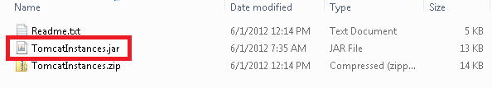
- Double click TomcatInstances.jar file to launch the application (Read readme.txt to know how to configure running of jar files on Linux and Windows)
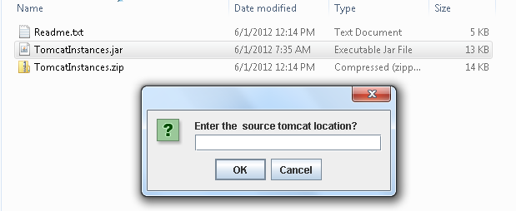
- Enter the location of <tomcat_home> which contains tomcat installation for which multiple instances are to be created.
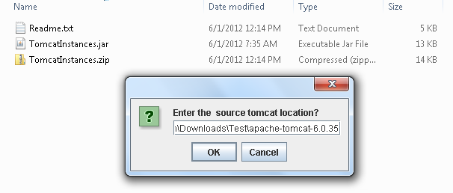
- The tool needs to copy some files and folders from the source tomcat to create multiple instances. You need to specify a directory where you will see directories being created corresponding to each tomcat instance.
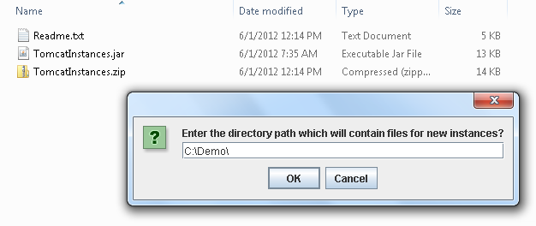
- If the location specified in this step doesn't exist, the tool can create it for you.

- Specify the number of instances to be created from the source tomcat
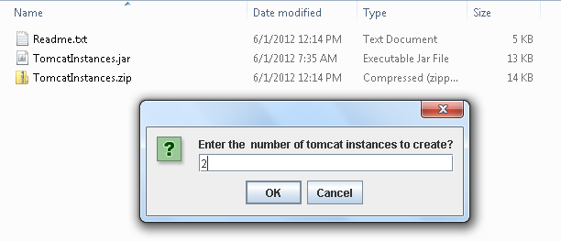
- There are three port numbers which have to be separate for each tomcat instance and the user needs to provide the port values for:
a) HTTP Connector: This is the port which is used for listening to HTTP requests
b) AJP port: This is the port where the communication between tomcat and and any other web server can happen using the AJP protocol
c) Shutdown port: This is the port where tomcat listens for shutdown events.
You can use the numbers similar to the default values. For e.g. default value for HTTP connector port is 8080 and one can use 5050. Default value for AJP connector port is 8009 and one can use 5009, default value for shutdown port is 8005 and one can use 5005
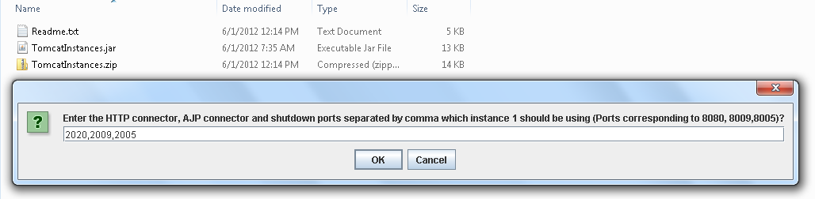
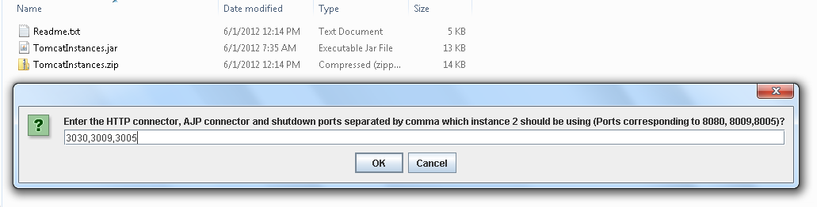
8) Once all the required information has been entered, the tool will do some file operations and hence can take some time to perform the job. Once the setup is done, you will get success message.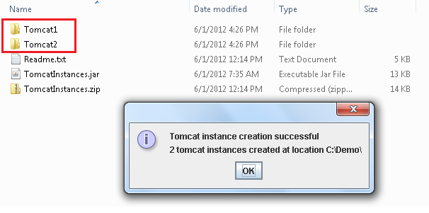
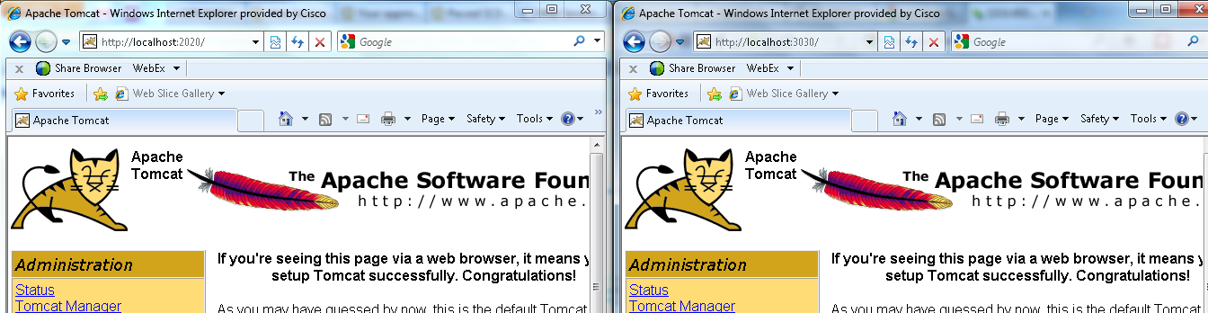
9) The tool gives error messages when it cannot proceed further.

*Please read readme.txt included with the application archive

